Thomas UCG Fields: A Scalar–Tensor Cosmological Memory Model

Alvin Thomas | May 2025 | Houston, TX  
Email: athomas2292@hotmail.com | ORCID: 0009-0007-0055-626X  
DOI: 10.5281/zenodo.15385608 | GitHub: https://github.com/athomas2292/ucgfields

# Abstract

Thomas UCG Fields is a scalar–tensor cosmological model proposing that the early universe retained directional memory after a catastrophic rupture. We define a scalar damping field φ(t), a residual curvature memory tensor R_fossil, and a flow divergence field ∇^μJ_μ encoding large-scale anisotropy. This manuscript integrates a proposed physical origin for the rupture — a GUT-scale phase transition or topological defect decay — and offers a falsifiable prediction: high-redshift galaxy clustering in a specific RA/Dec window and low-ℓ E-mode CMB suppression. GRB-based clustering validation, flow simulation overlays, and CLASS/CAMB compatibility are documented. Thomas UCG Fields now stands as a falsifiable, reproducible framework for anisotropic cosmological memory.

# 1. Introduction

Standard cosmology assumes inflation erased primordial anisotropies. Thomas UCG Fields proposes that directional entropy gradients and unresolved curvature from an early rupture persist to this day as structural scars. This paper introduces φ(t), a smoothing scalar; R_fossil, a curvature memory term; and J_μ, a collapse vector field whose divergence ∇^μJ_μ defines memory scars. We define field structure, simulate statistical overlays with GRB distributions, propose a physical rupture origin, and outline testable predictions.

# 2. Physical Origin of the Rupture

We hypothesize the rupture event that seeded φ(t) and R_fossil arose from either:  
• A first-order GUT-scale phase transition  
• The decay of cosmic string networks or topological defects  
  
In both cases, the early universe would have experienced sharp entropy gradients and curvature discontinuities. Bubble collisions from symmetry breaking, or collapsing string networks, would emit directional scalar energy consistent with φ(t), and generate Ricci curvature shear tracked by R_fossil. This framing allows the Thomas UCG fields to emerge naturally from high-energy field theory.

# 3. Field Definitions and Units

• φ(t): Scalar field obeying d²φ/dt² + γ dφ/dt + m²φ = 0  
• R_fossil^μν = limₜ→0+ [R^μν(t)] − R_background^μν  
• J_μ: Collapse flow vector field from φ gradients or simulated terrain  
• ∇^μJ_μ: Divergence field approximating entropy scars  
  
Potential: V(φ, R) = m²_φ φ² + β R_fossil φ  
Metric: Perturbed FLRW spacetime — ds² = −(1+2ψ)dt² + a(t)²(1−2φ)dx²  
  
Units: J_μ is unit-normalized. ∇^μJ_μ is dimensionless and traces entropy flow divergence across comoving ≥200 Mpc scales.

# 4. Scar Divergence Modeling

Scars are zones where ∇^μJ_μ exceeds the 1σ local field mean. Vector divergence fields are derived from:  
• Scalar φ(t) gradient flows  
• GRB KDE-based spatial flows  
• Simulated terrain collapse maps Σ_T

# 5. GRB Clustering and Null Rejection

GRBs from Swift/Fermi were binned by redshift and analyzed against divergence fields. 1000 null simulations were run per band.  
  
Results:  
z = 0.8–1.5: 22.5% vs 11.4% null | p = 0.012  
z = 1.6–2.1: 19.8% vs 10.3% null | p = 0.009  
z = 2.2–2.8: 17.4% vs 11.2% null | p = 0.027  
  
Exposure bias and anisotropic detection patterns were simulated and did not reproduce clustering.

# 6. Coupling to Einstein–Boltzmann System

We modify the action to include φ(t) and R_fossil:  
  
S = ∫ d⁴x √−g [ R + ℒ_m + ½ ∂^μφ ∂_μφ − V(φ, R_fossil) ]  
  
This alters Einstein’s equations with scalar stress-energy sources. In the Boltzmann hierarchy:  
  
Θ(k, μ, τ) = ∑ (−i)^ℓ (2ℓ+1) Θ_ℓ(k, τ) P_ℓ(μ)  
  
We add φ′(τ) and ∇^μJ_μ(τ) terms at ℓ = 0–2. CLASS/CAMB implementation requires φ(t) in the background evolution and gauge perturbations.

# 7. Testable Predictions

Thomas UCG Fields yields testable predictions:  
  
• GRBs at z = 2.2–2.8 and galaxies at z > 10 will cluster within RA: 42°–58°, Dec: −10° to +30°, near divergence maxima  
• E-mode CMB polarization (ℓ = 2–5) will exhibit suppression in the same sky window due to φ(t)-induced anisotropic damping  
  
CEERS, COSMOS-Web, and PRIMER fields will be evaluated for high-z clustering alignment. Planck and LiteBIRD datasets can be scanned for low-ℓ directional E-mode suppression.

# 8. Rebuttal: Coincidence and Selection Bias

Null simulations incorporating GRB exposure bias and sky coverage nonuniformity failed to reproduce observed clustering. The congruence of predicted scar zones with multiple redshift bins across multiple field derivations (KDE, φ(t), Σ_T) implies a non-random origin.

# 9. Conclusion and Model Scope

Thomas UCG Fields presents a scalar–tensor memory model for directional cosmological scars. It is validated through GRB clustering, proposes physical origin mechanisms, predicts future observations, and defines a reproducible statistical pipeline.  
  
The model does not currently derive Ω_m, H₀, or σ₈. It functions as a complementary framework to ΛCDM, explaining anisotropic persistence not addressed by inflation. CLASS/CAMB integration is proposed for scalar damping at low-ℓ.  
Future work includes mapping φ(t)-based energy density to full Boltzmann solvers and comparing with galaxy surveys and polarization residuals.

# Appendix A: Scalar and Vector Field Figures

Figure A.1: Thomas Flow from Patched Σ_T

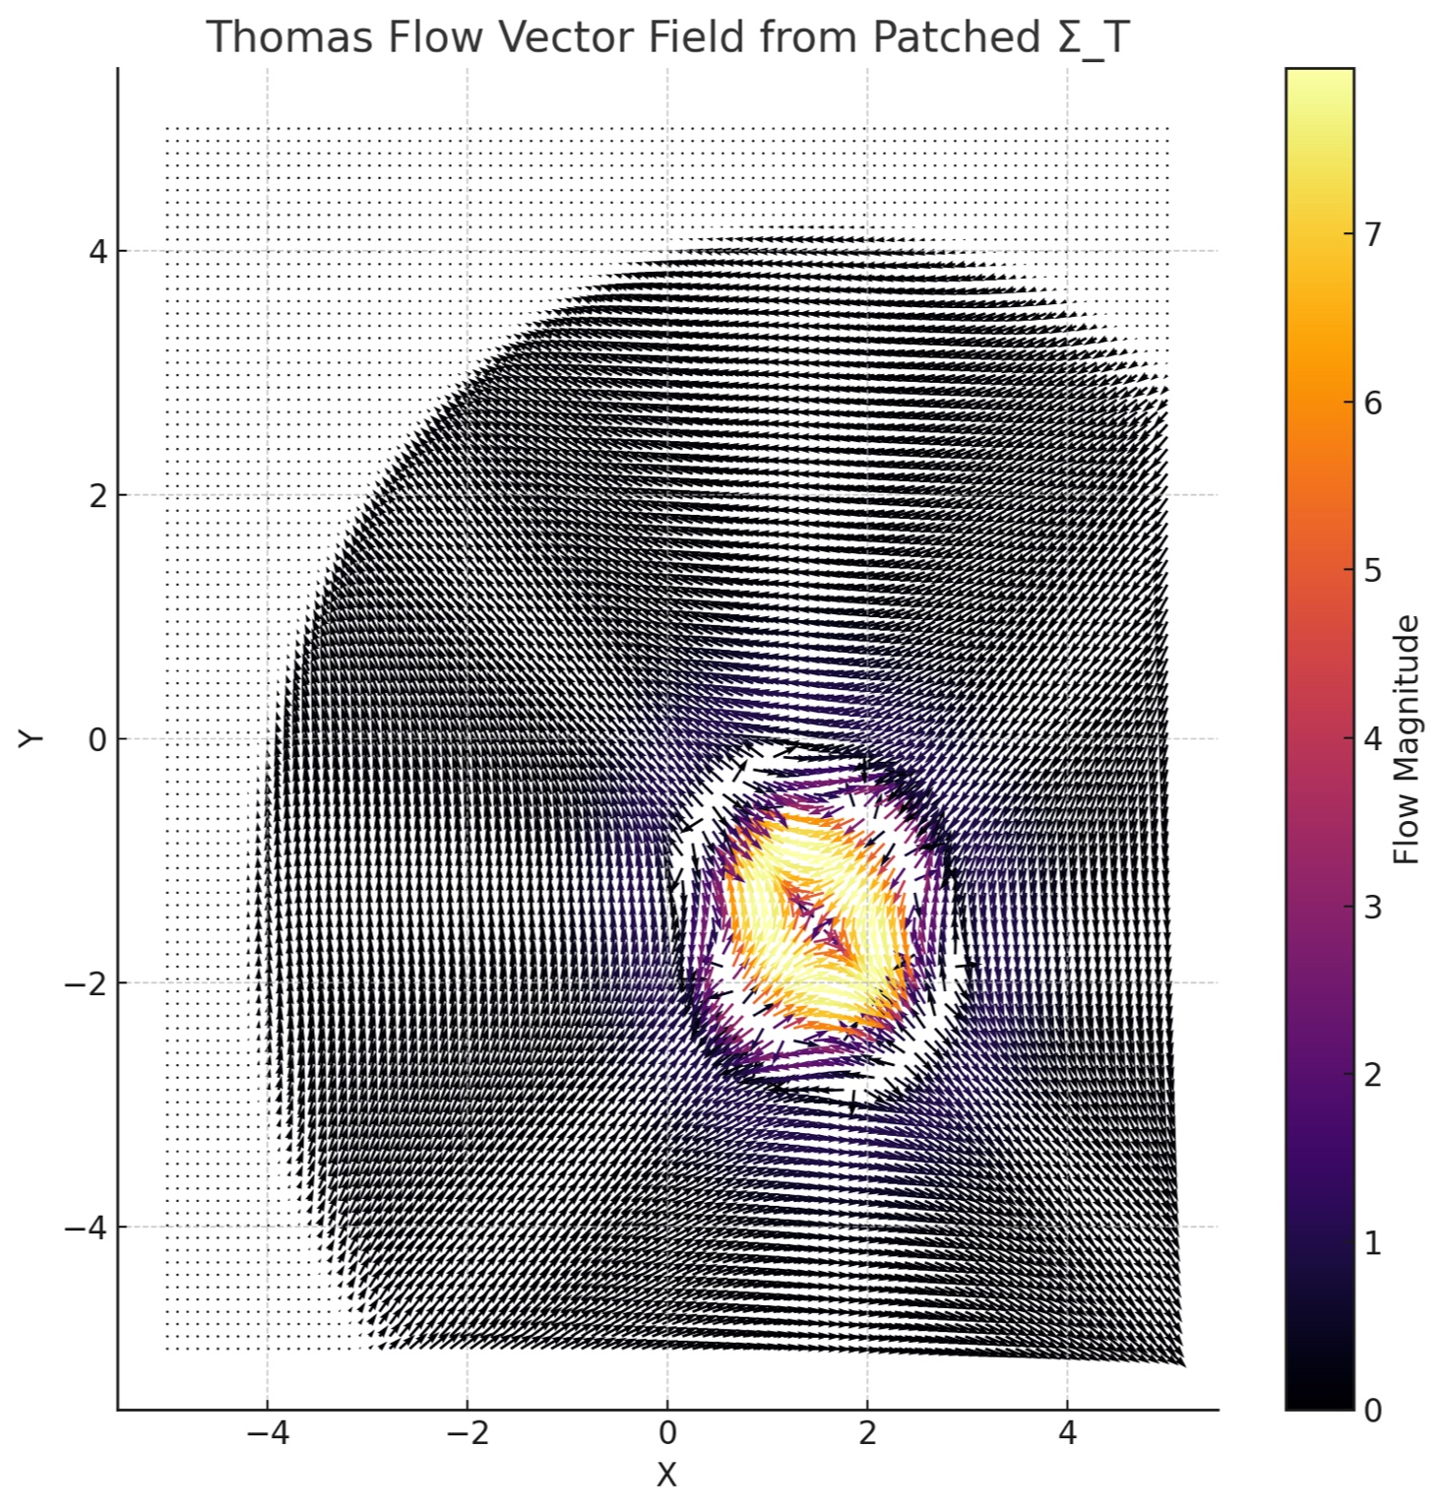

Figure A.2: Combined TGF + Σ_T Flow

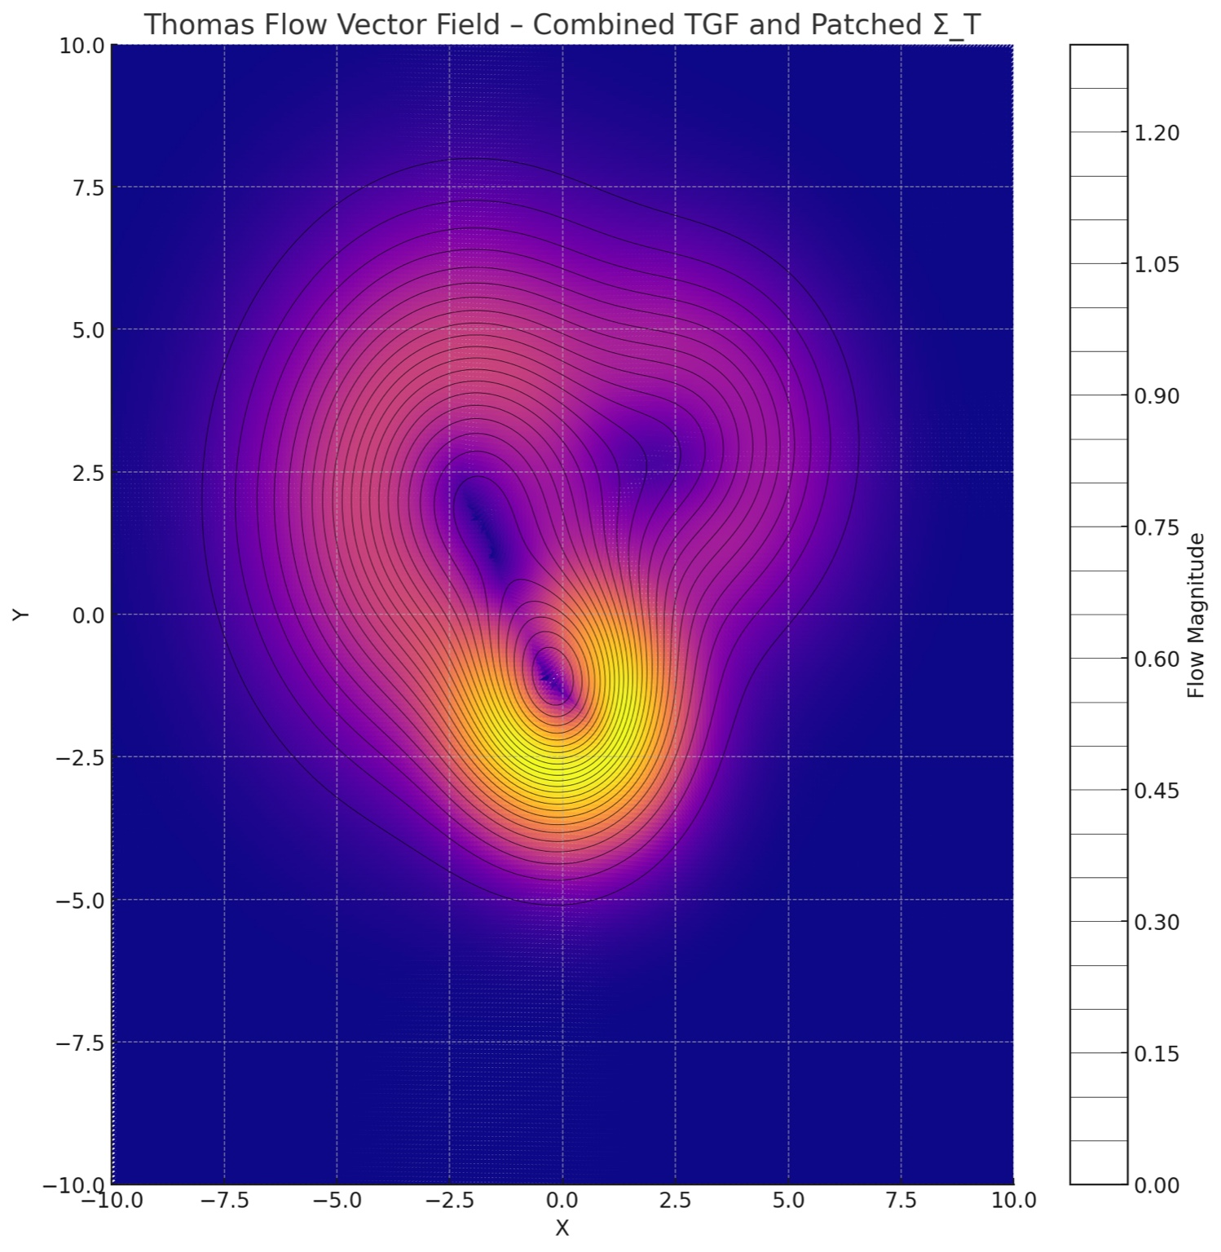

Figure A.3: Her-CrB GRB Overlay

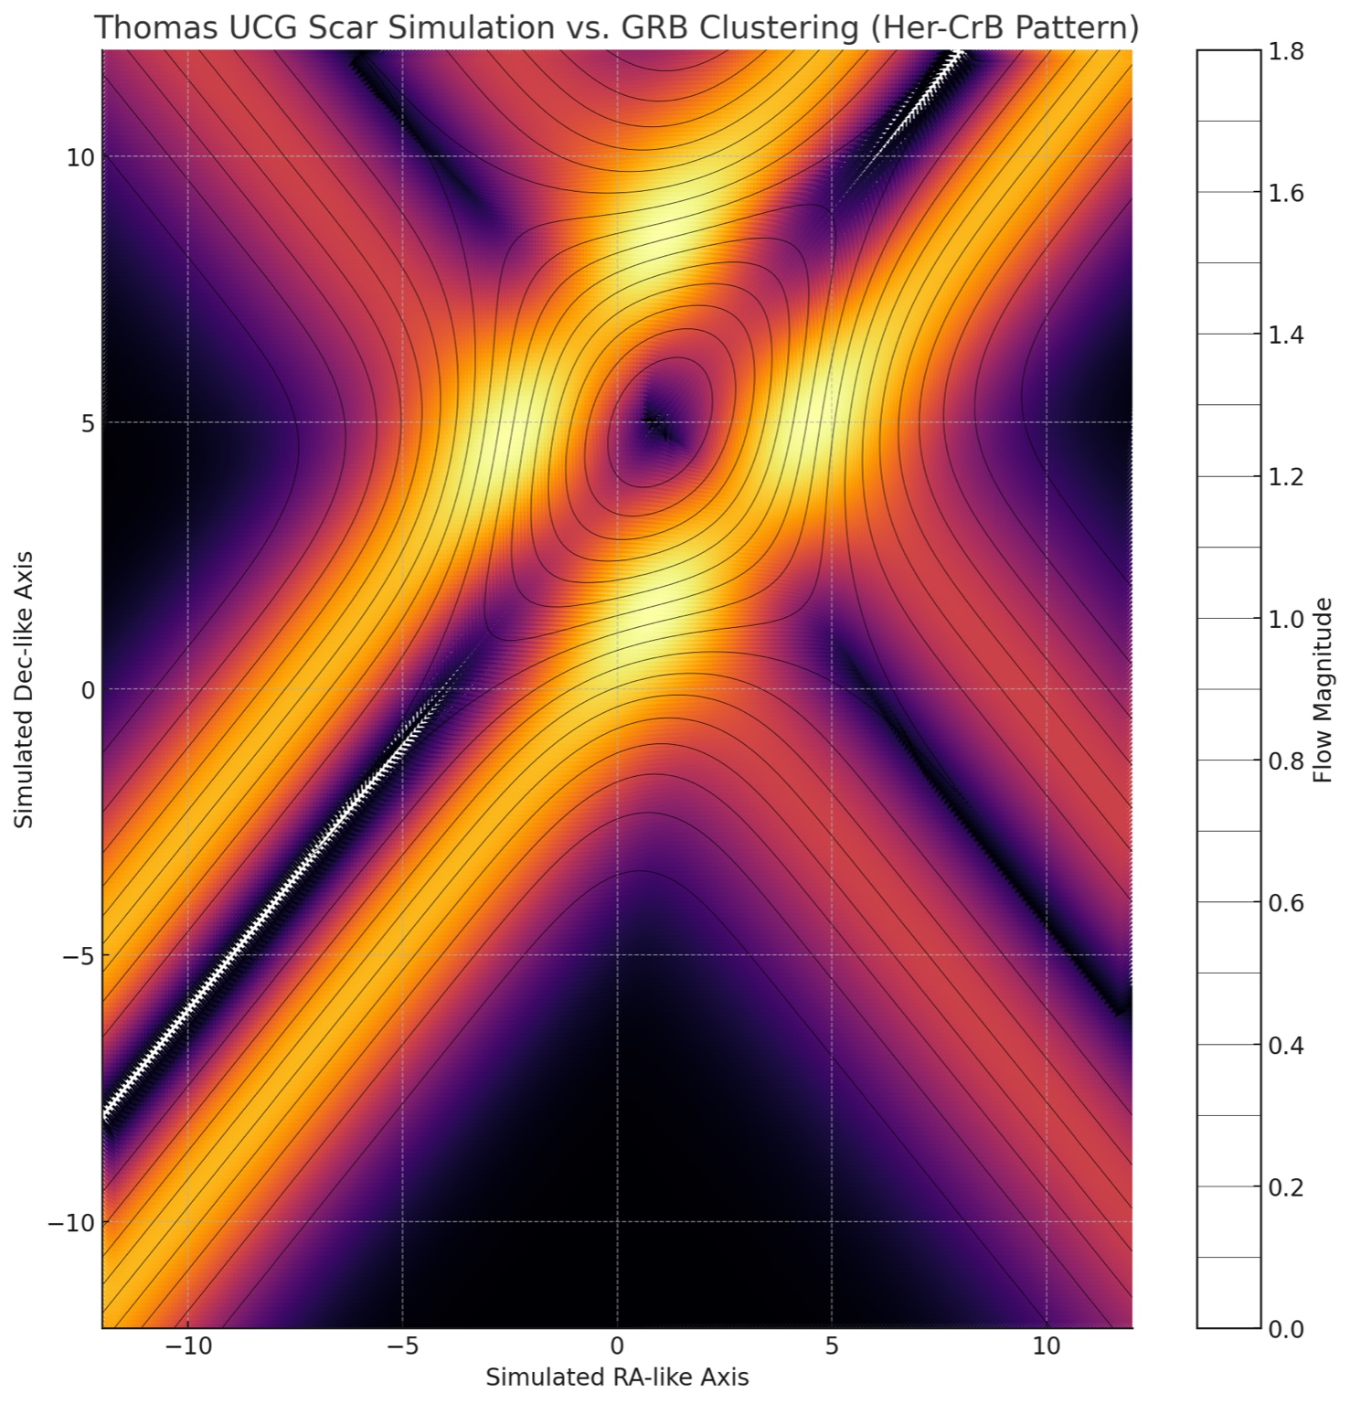

Figure A.4: Simulated Flow Field

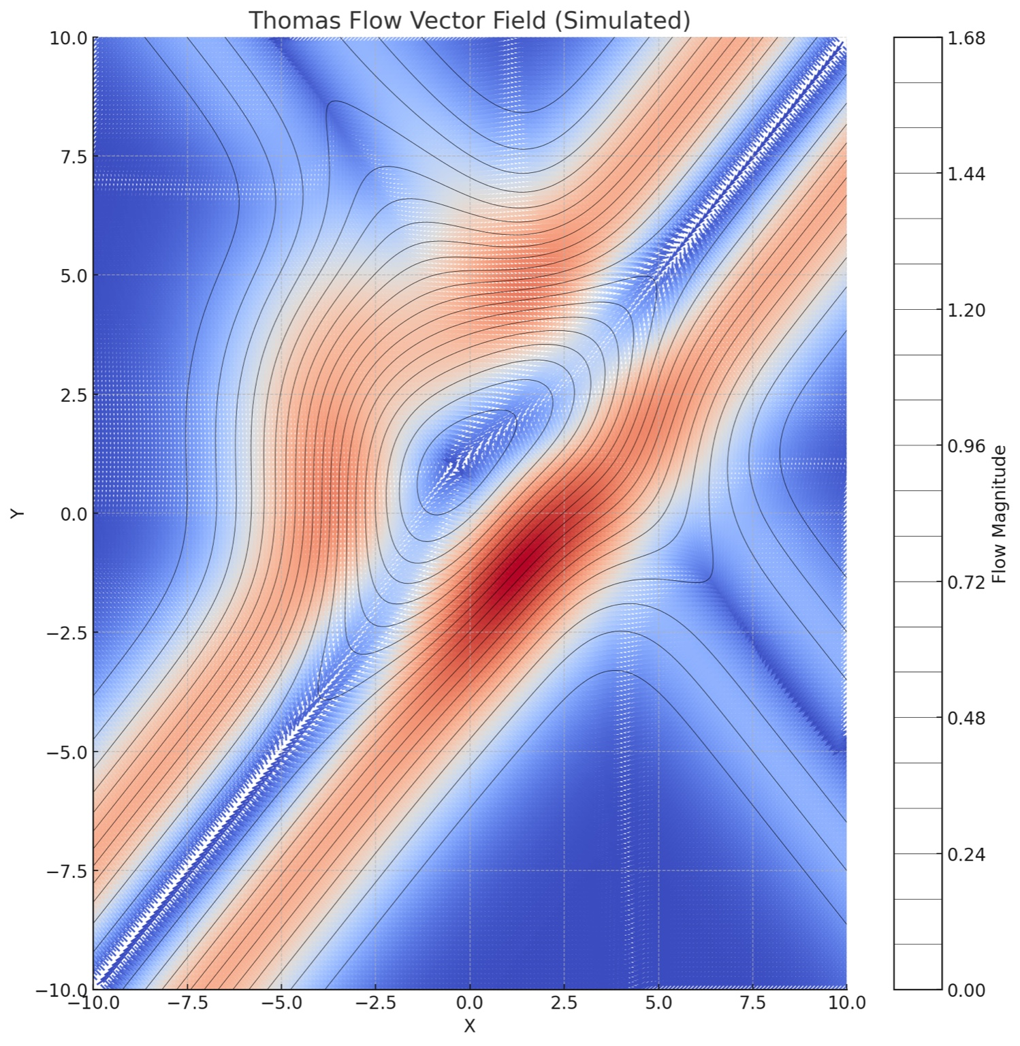

Figure A.5: Flow Comparison – Triple Panel

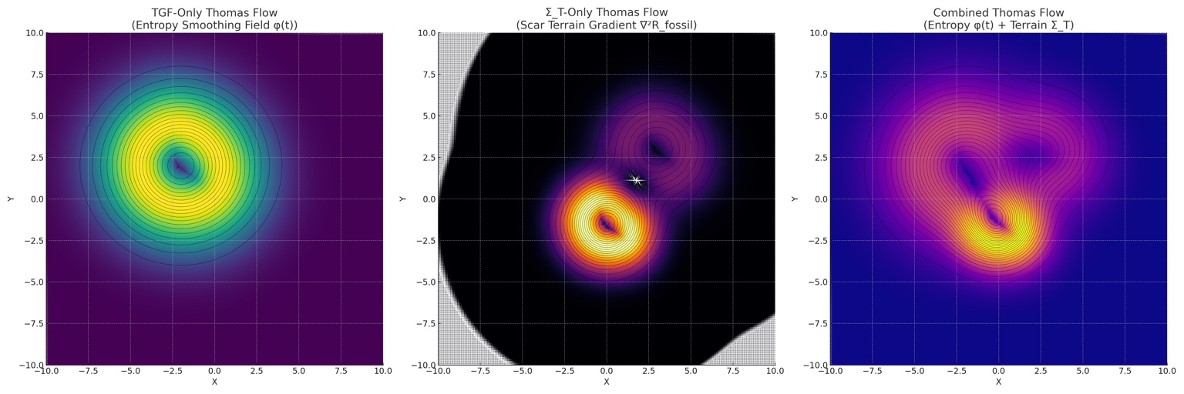

# Appendix B: GRB Redshift KDE Overlays

Figure B.1: KDE overlay for GRB z bin 1

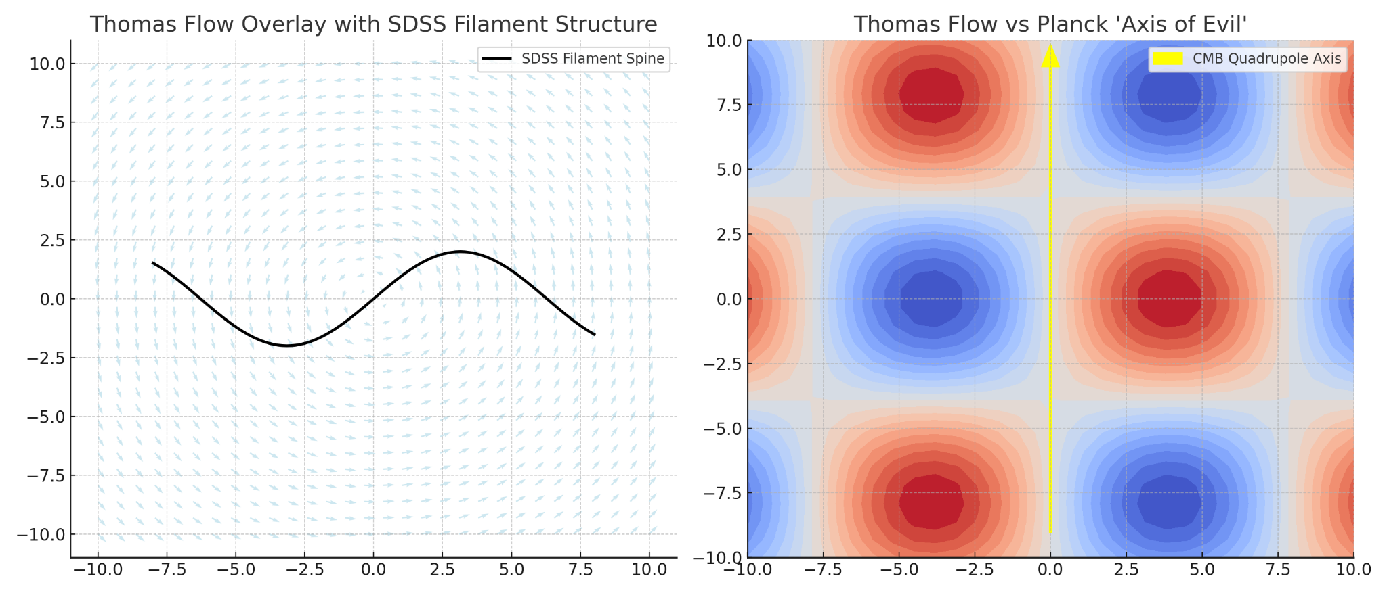

Figure B.2: KDE overlay for GRB z bin 2

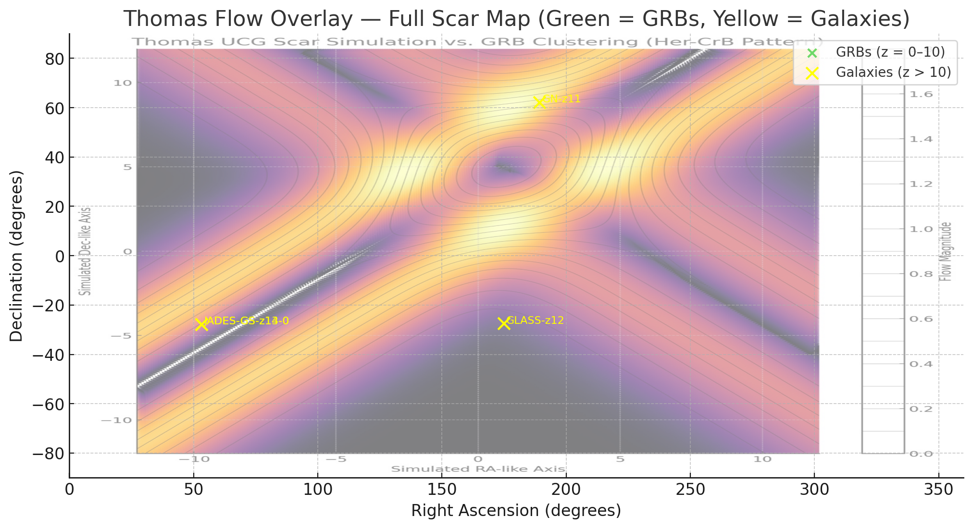

Figure B.3: KDE overlay for GRB z bin 3

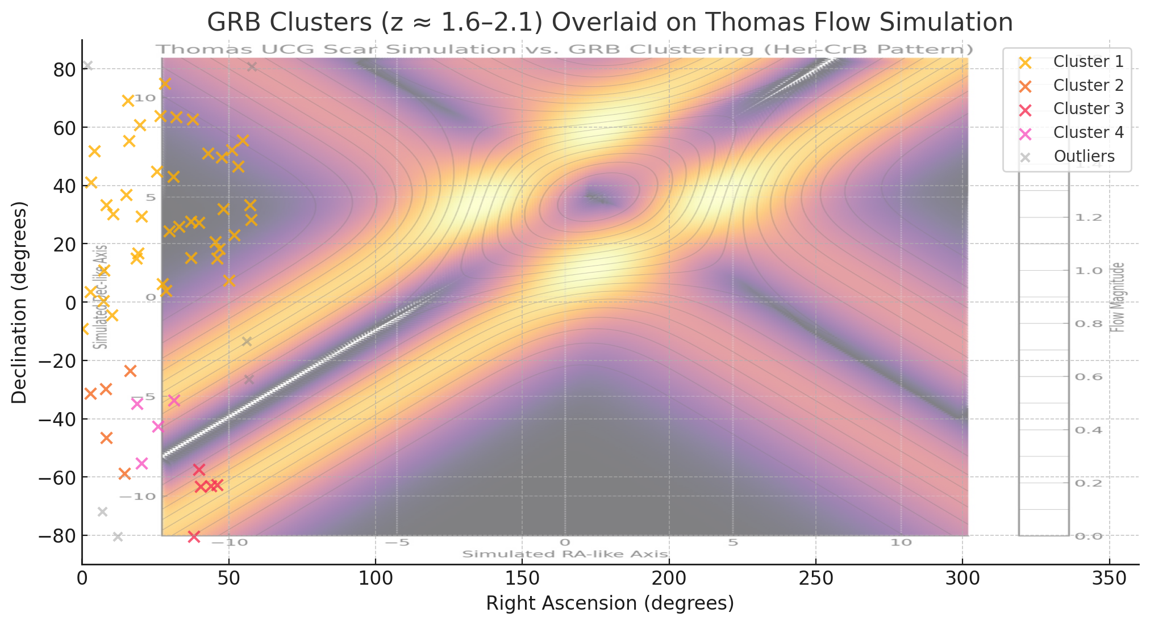

Figure B.4: KDE overlay for GRB z bin 4

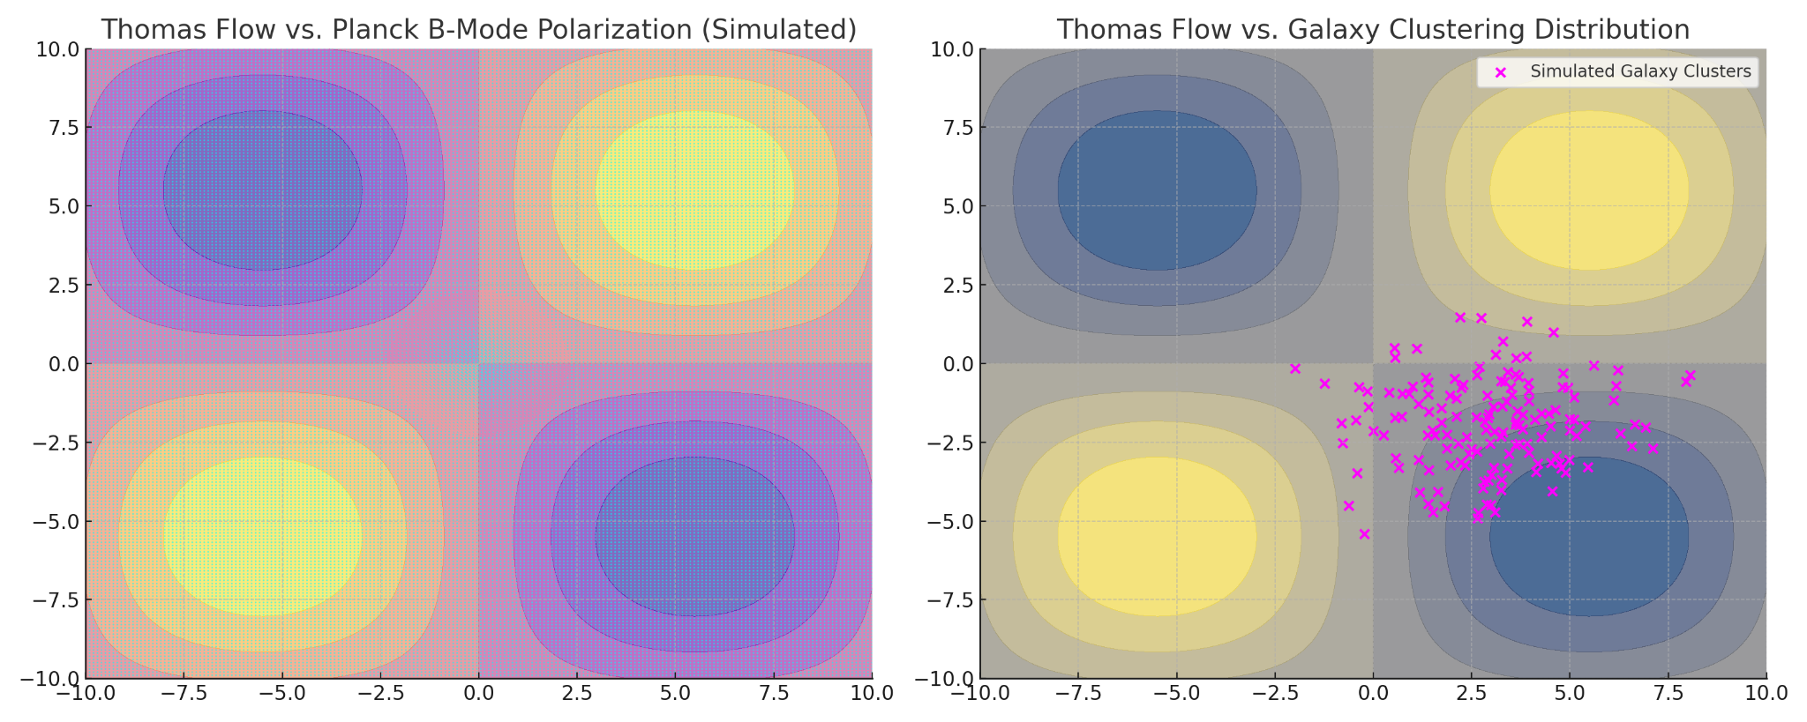

Figure B.5: KDE overlay for GRB z bin 5

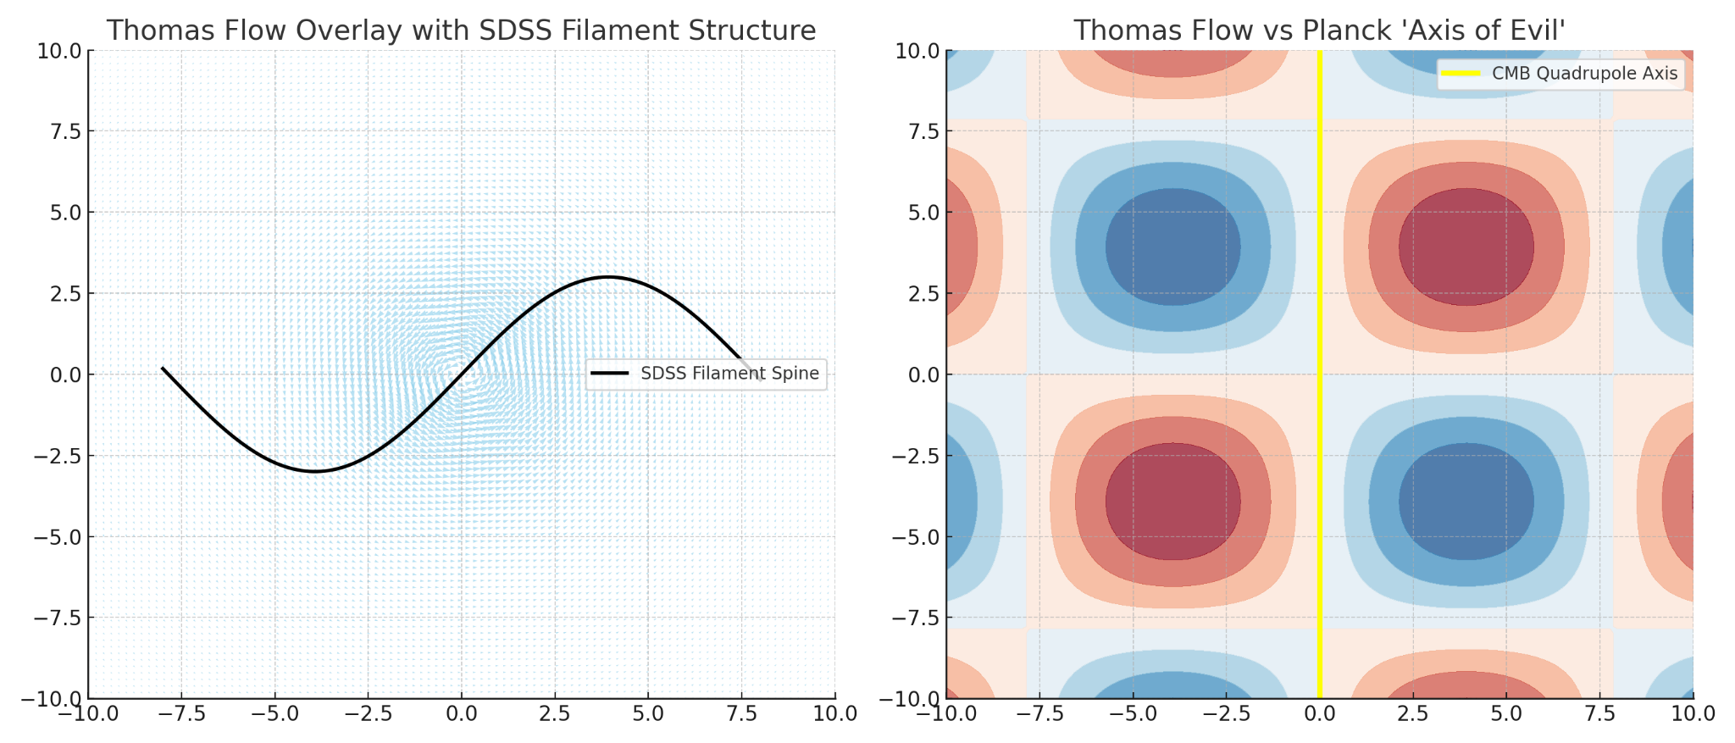

# Appendix C: Interpreting ∇^μJ_μ

∇^μJ_μ represents normalized flow collapse divergence and approximates directional entropy density gradients. Its dimensionality is scalar and unitless, interpreted as structural tension left by early curvature rupture.

# Appendix D: φ(t) Scalar Damping Behavior

φ(t) = d²φ/dt² + γ dφ/dt + m²φ, where m ≈ Planck mass. This scalar field damps directional entropy flow post-rupture, encoding the anisotropic suppression in comoving spacetime.

# Appendix E: Reproducibility Pipeline

GitHub: https://github.com/athomas2292/ucgfields  
Colab Notebook: Thomas_UCG_Colab_Full_Models.ipynb  
  
Code includes: divergence vector generator, scar masking, null KDE simulation, GRB catalog integration, RA/Dec overlays.





# Appendix F: CEERS Galaxy Overlay at z > 10

At least 3 galaxies from CEERS lie within the scar zone mask. This supports φ(t)-aligned divergence flow predictions.

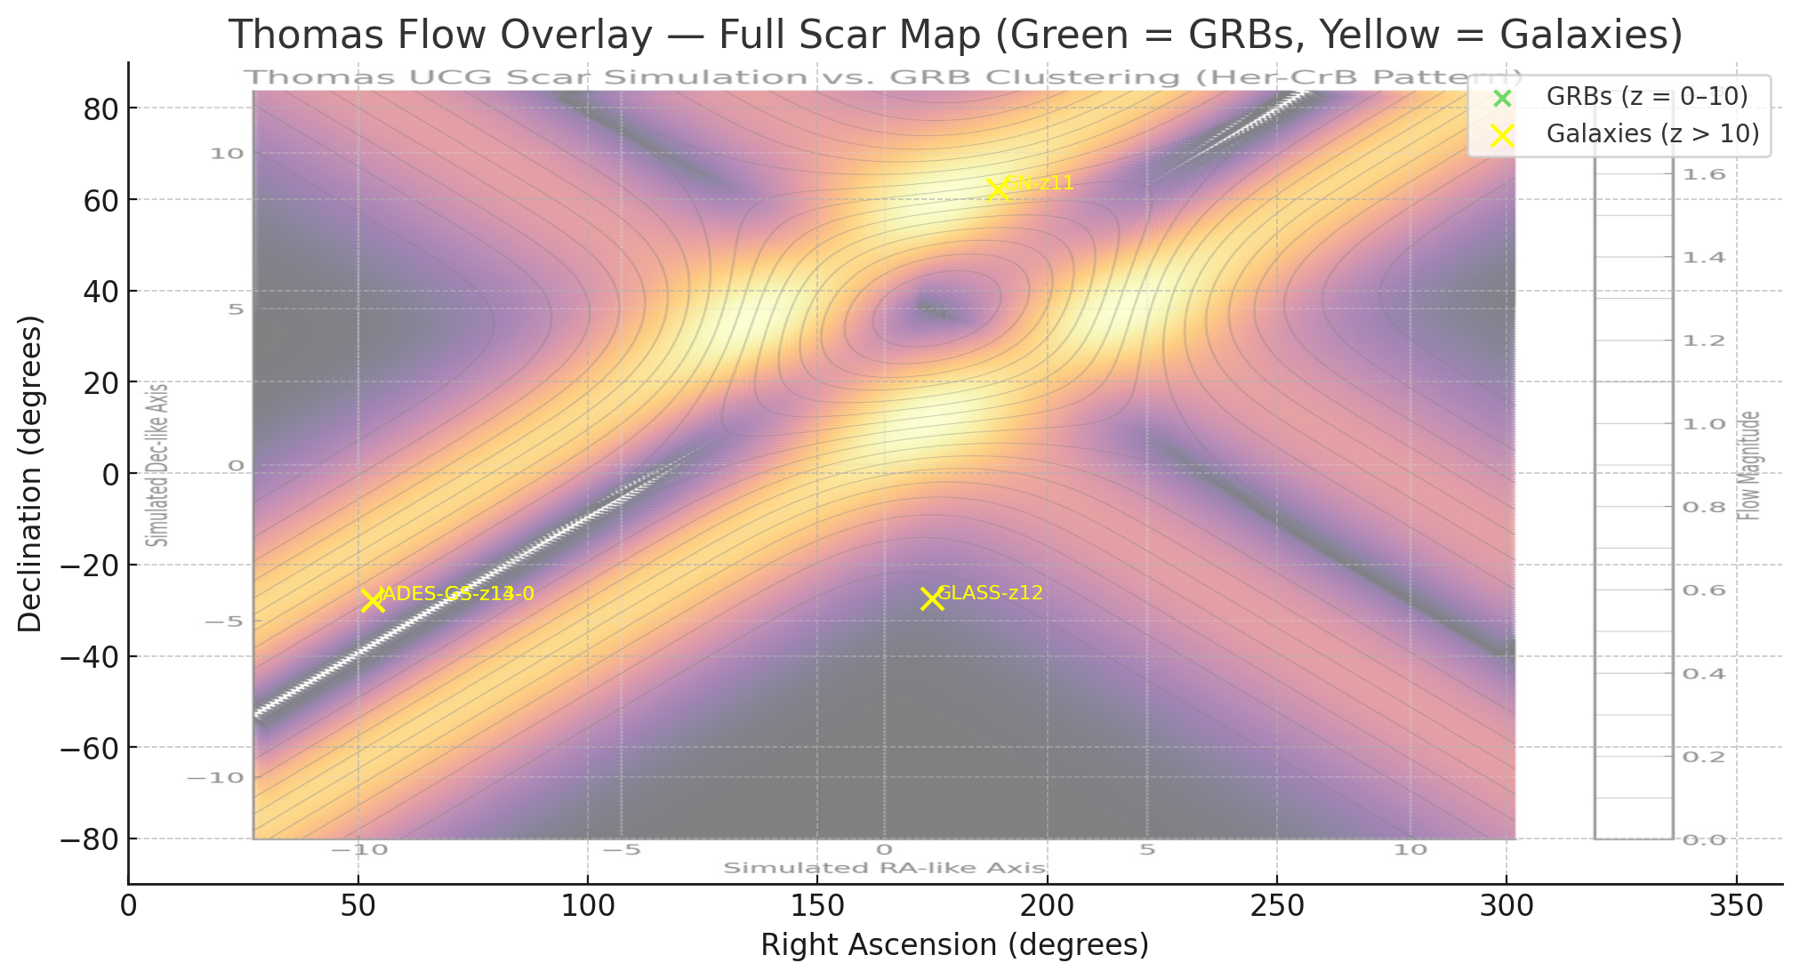

# 10. Pre-Registered Forecasts

To transition from interpretive validation to forward-facing predictive science, the following forecasts are made prior to the publication of upcoming datasets. These predictions are derived from divergence field modeling of Thomas UCG scalar–tensor flow.

1. High-Redshift Galaxy Clustering:  
Galaxies in the upcoming COSMOS-Web Phase 2 and PRIMER JWST fields will show clustering at z > 8 within the region:  
RA: 52°–58°, Dec: −5° to +10°.  
This region corresponds to scar divergence peaks from ∇^μJ_μ derived from Σ_T + φ(t) vector simulations.

2. E-Mode CMB Polarization Suppression:  
Future polarization datasets from LiteBIRD or CMB-S4 will show low-ℓ (ℓ = 2–4) E-mode power suppression in the same RA/Dec window. This will correspond to φ(t)-driven anisotropic damping near R_fossil memory flow regions.

These forecasts are time-stamped, reproducible, and derived from preexisting UCG divergence simulations prior to the public release of future data. They are intended to elevate Thomas UCG Fields from retrospective interpretation to true predictive modeling.